
Cloudera Navigator Access

08-24-2015

Cloudera Navigator
Cloudera Navigator is a fully integrated data management tool for the EDL Hadoop platform. Its two major functionalities are searching metadata and visualizing data lineage.

Cloudera Navigator Access
Cloudera Navigator offers three different roles to Application users based on the user’s job requirements and their needs. The roles are Policy Administrator, Policy Viewer and Lineage Viewer. Policy Administrator shall have the elevated privileges and would be able to create, modify and drop policies on system wide data and hence this access should be provisioned to the users/analysts who have some background knowledge about Cloudera Navigator policies and its maintenance.
In order to gain access to the Cloudera Navigator user shall submit the access request to the below AD groups.
DEV Environment:
ITS-EDL-DEV-NAV-POLICY-ADMIN-USR (Power users only shall apply)
This AD group should be applied only by the power users from the Application team. Policy Administrators shall be able to View, create, update, and delete metadata policies.

ITS-EDL-DEV-NAV-POLICY-VWR-USR
Users shall be able to view metadata policies.

ITS-EDL-DEV-NAV-LINEAGE-VWR-USR
User shall be able to search for entities, view metadata, and view lineage.
QA Environment:
ITS-EDL-QA-NAV-POLICY-ADMIN-USR (Power users only shall apply)
This AD group should be applied only by the power users from the Application team. Policy Administrators shall be able to View, create, update, and delete metadata policies.

ITS-EDL-QA-NAV-POLICY-VWR-USR
Users shall be able to view metadata policies.

ITS-EDL-QA-NAV-LINEAGE-VWR-USR
User shall be able to search for entities, view metadata, and view lineage.
PROD Environment:
ITS-EDL-PROD-NAV-POLICY-ADMIN-USR (Power users only shall apply)
This AD group should be applied only by the power users from the Application team. Policy Administrators shall be able to View, create, update, and delete metadata policies.

ITS-EDL-PROD-NAV-POLICY-VWR-USR
Users shall be able to view metadata policies.

ITS-EDL-PROD-NAV-LINEAGE-VWR-USR
User shall be able to search for entities, view metadata, and view lineage.

Requesting Membership to the Group
Using the “Get Access to a Resource” workflow.
- Point your browser to http://myapps.jnj.com.
- Log in using your own network account and password.
- Click on “Self Service” on the main menu.
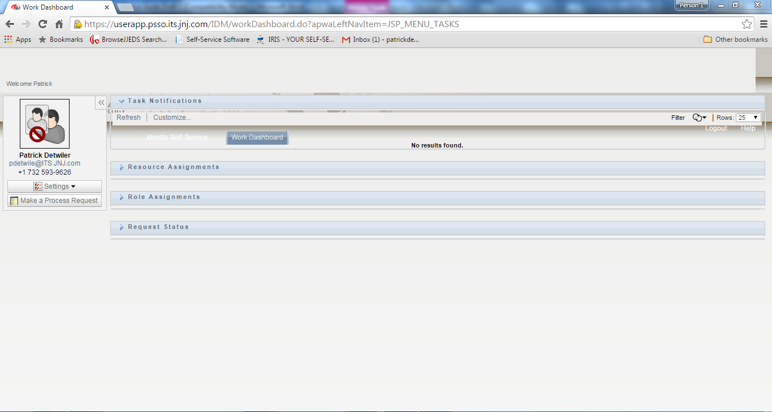

- On the left hand panel click on “Make a Process Request.”

- Select “Self Service” under Process Request Category pull down menu and click “Continue.”
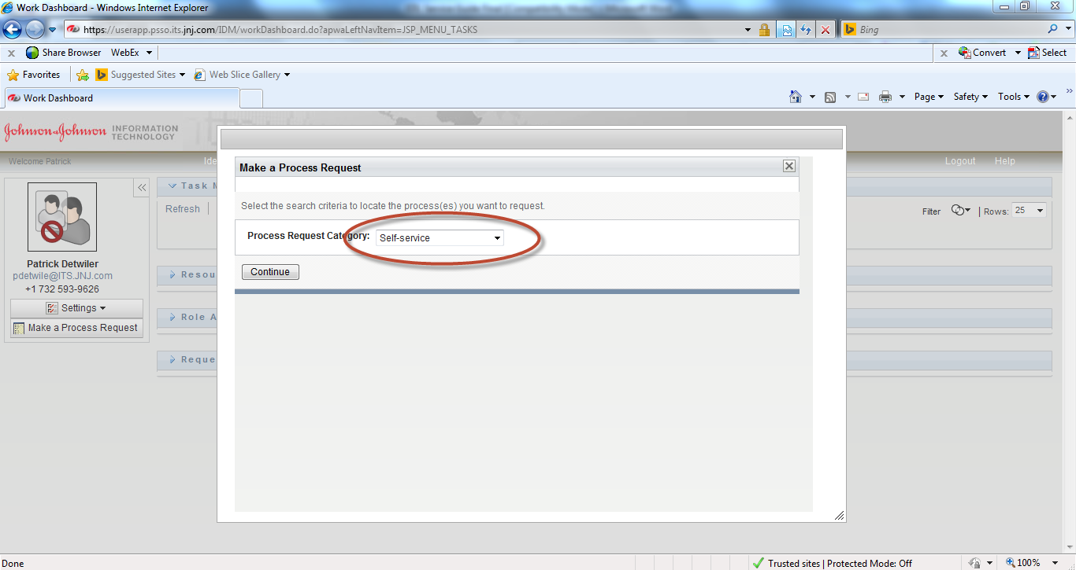

- Click on “Get Access To a Resource”.
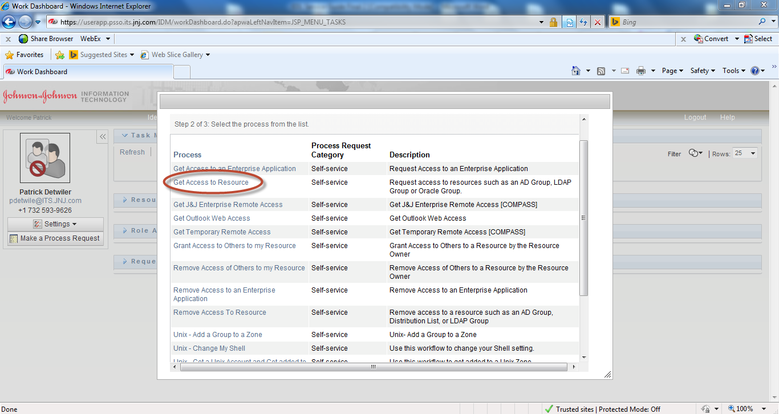
- Select “Primary” for account type.
- Select “AD Groups” for Resource Category and “Security Group” for Resource type.
- Type a partial or full name of the group based on your requirement in “Search Filter” and press <TAB>.
- Select the Group, from “Available resources.”
- Provide a valid reason for the access and press “Submit.”
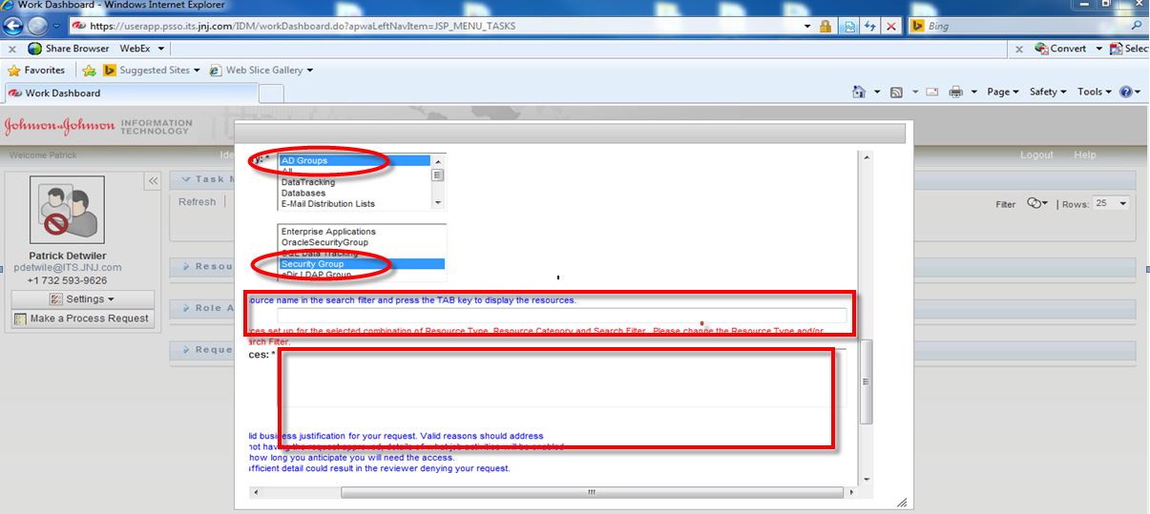
- The request is then routed for approval

Portals for the DEV, QA and PROD Navigator

DEV: https://itsusraedld01.jnj.com:7187/login.html
QA: https://itsusraedlq01.jnj.com:7187/login.html
PROD: https://itsusraedlp01.jnj.com:7187/login.html

Steps to View User Access Privileges

- Point your browser to https://itsusraedld01.jnj.com:7187/login.html
- Log in using your own network account and password
- Click the username in the upper right.

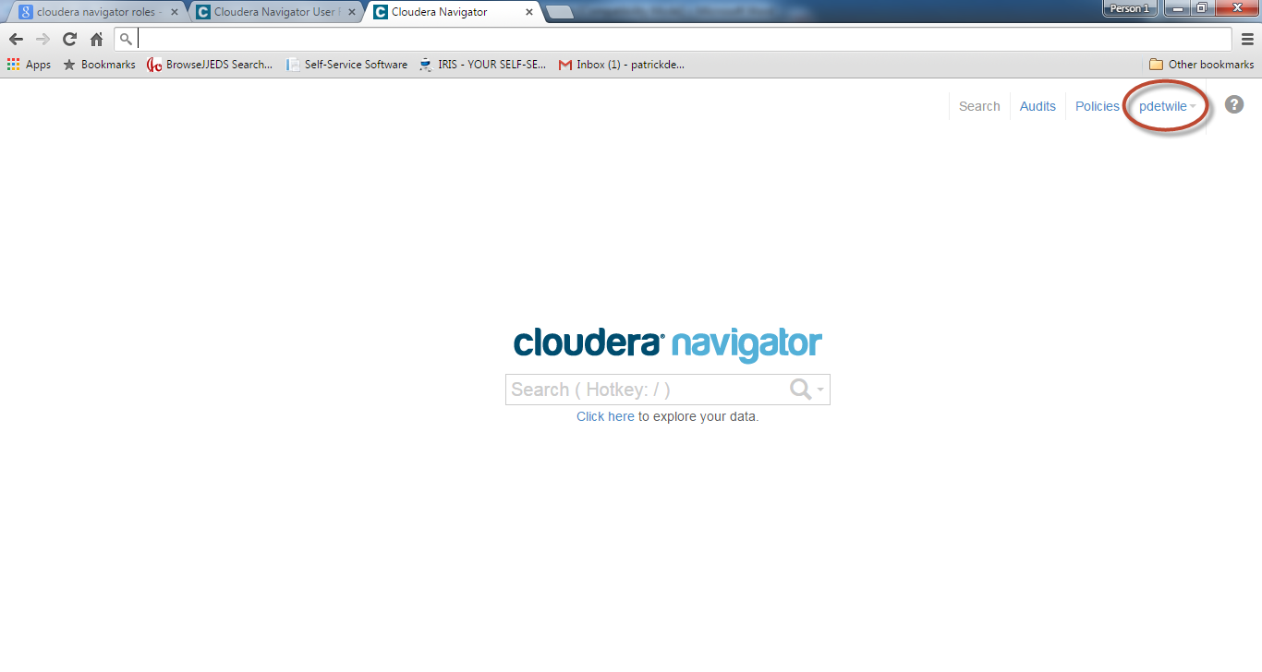
- Click My roles.
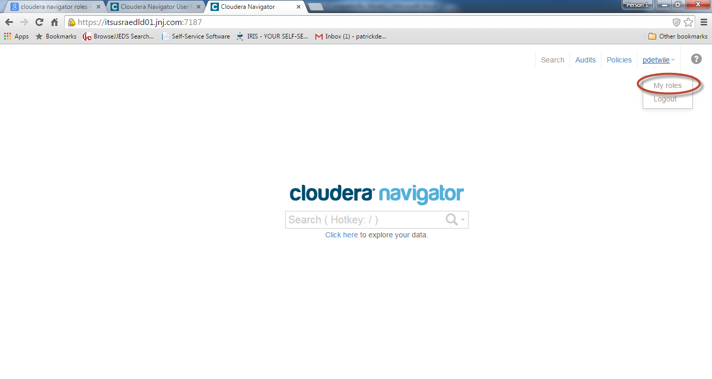
- The Roles pop-up window will appear, displaying all roles assigned to the LDAP or Active Directory groups to which the current user belongs.

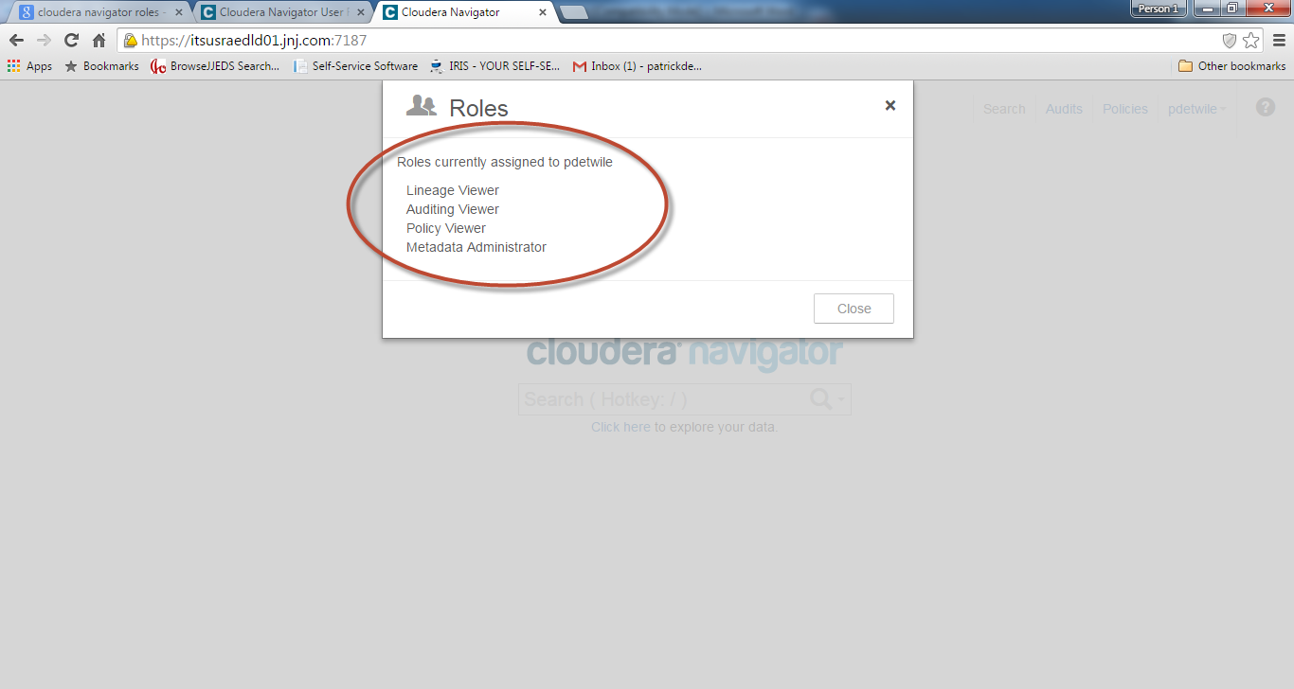
The selection of menus displayed in the upper right indicates the user's access to Cloudera Navigator features, as determined by the roles associated with the user's LDAP or Active Directory groups. For example, a Full Administrator will see the Search, Audits, Policies, and Administration menus, while a user with the Policy Administrator role will only see the Search and Policies menus.

Navigator functionalties
  - Data Lineage
Cloudera Navigator has the ability to answer questions such as: where did the data come from, where is it used, and what are the consequences of purging or modifying a set of data entities. Cloudera Navigator also supports tracking the lineage of HDFS files and directories, Hive tables and columns, MapReduce and YARN jobs, Hive queries, Pig scripts, Sqoop jobs, and Oozie workflows.

- Search for any criteria

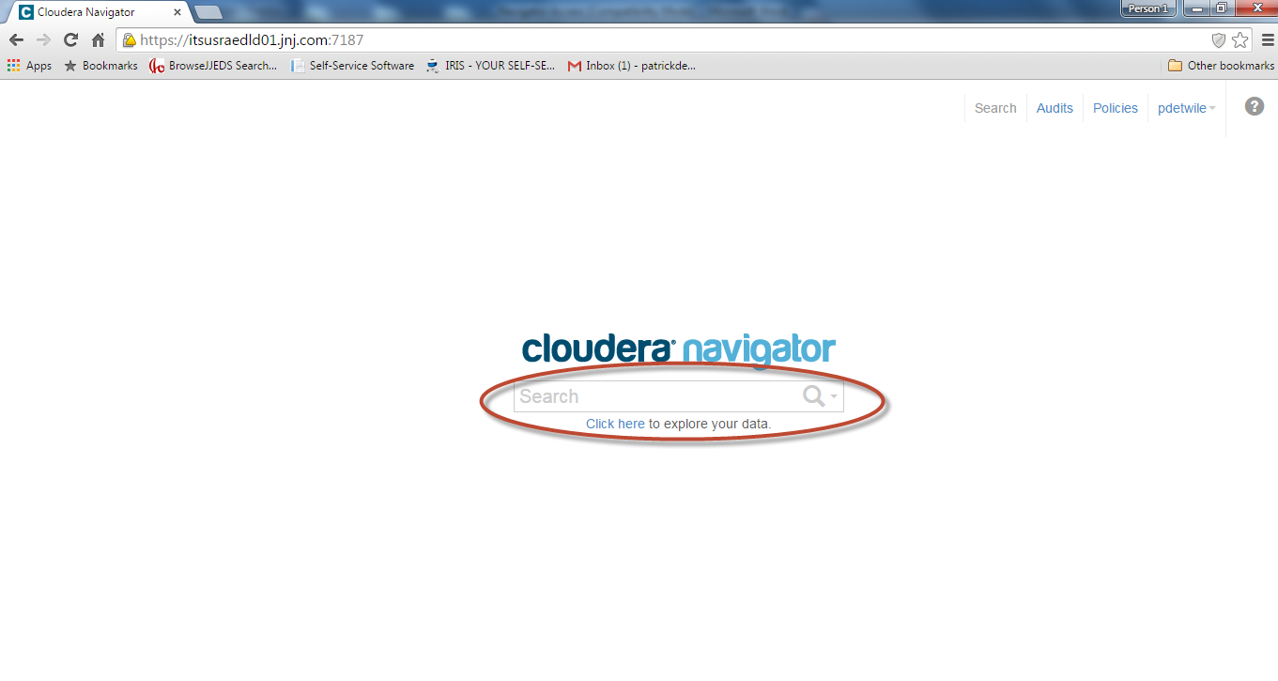

- Select the “Source Type” from the left column. For example, “Hive” is the selcted source

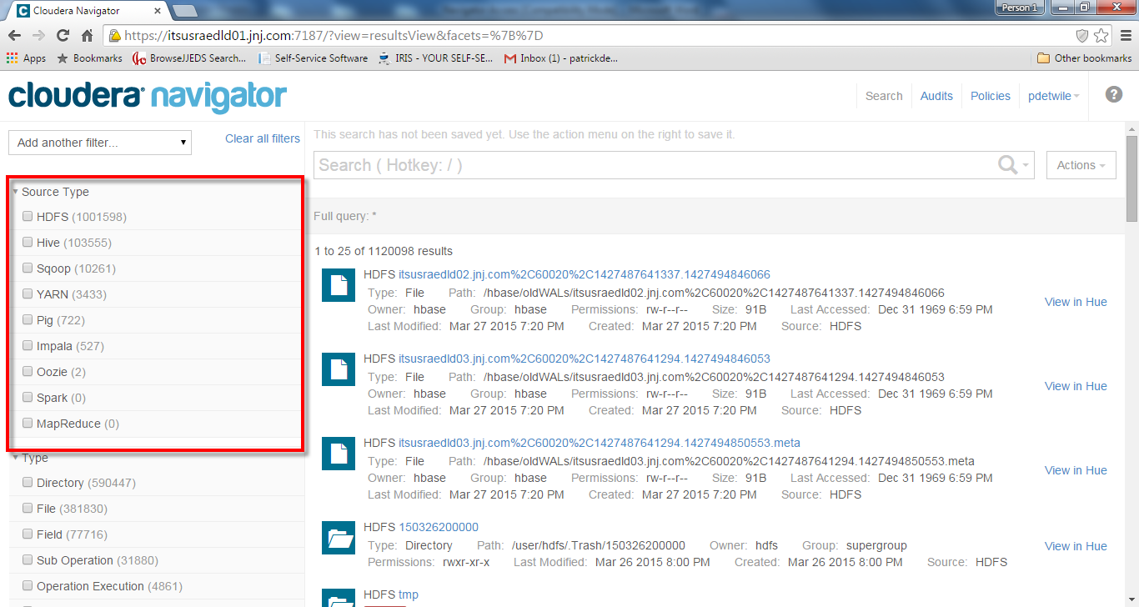

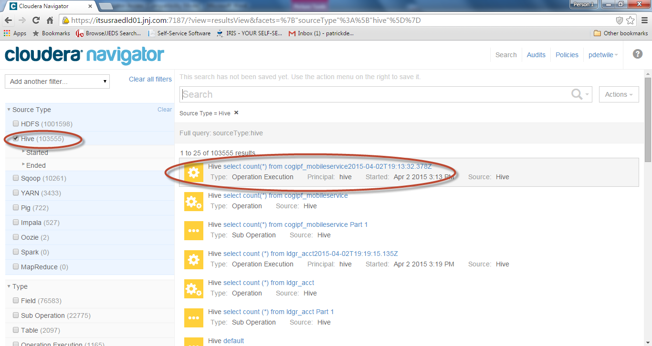

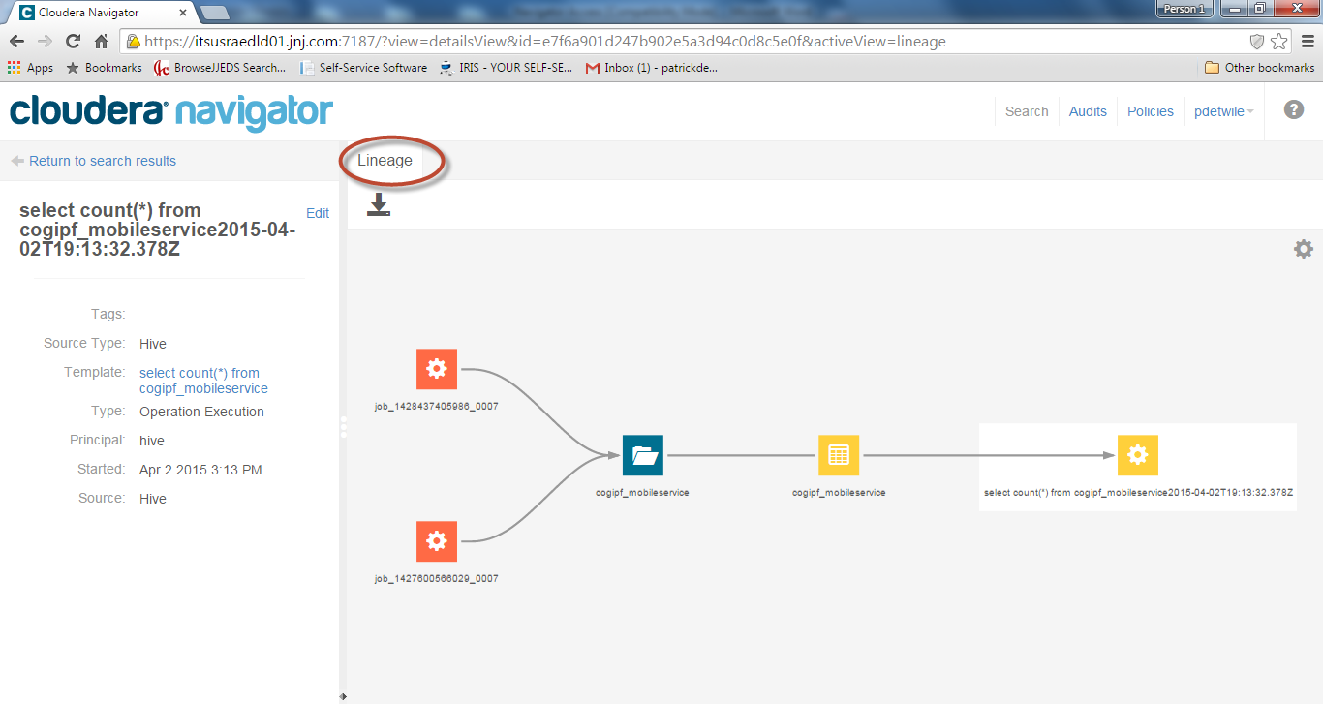

  - Metadata Policies
Cloudera Navigator metadata management features allow Data modelers, Business analysts, and
Data scientists to search for, amend the properties of, and tag data entities.

- Search for any criteria

- Select the “Source Type” from the left column. For example, “Hive” is the selcted source

3. You can search by any criteria via the Search bar.

4. Once you have located the file, you can click on the search result to view its lineage.

- To edit the file, click on the “Edit” tab.

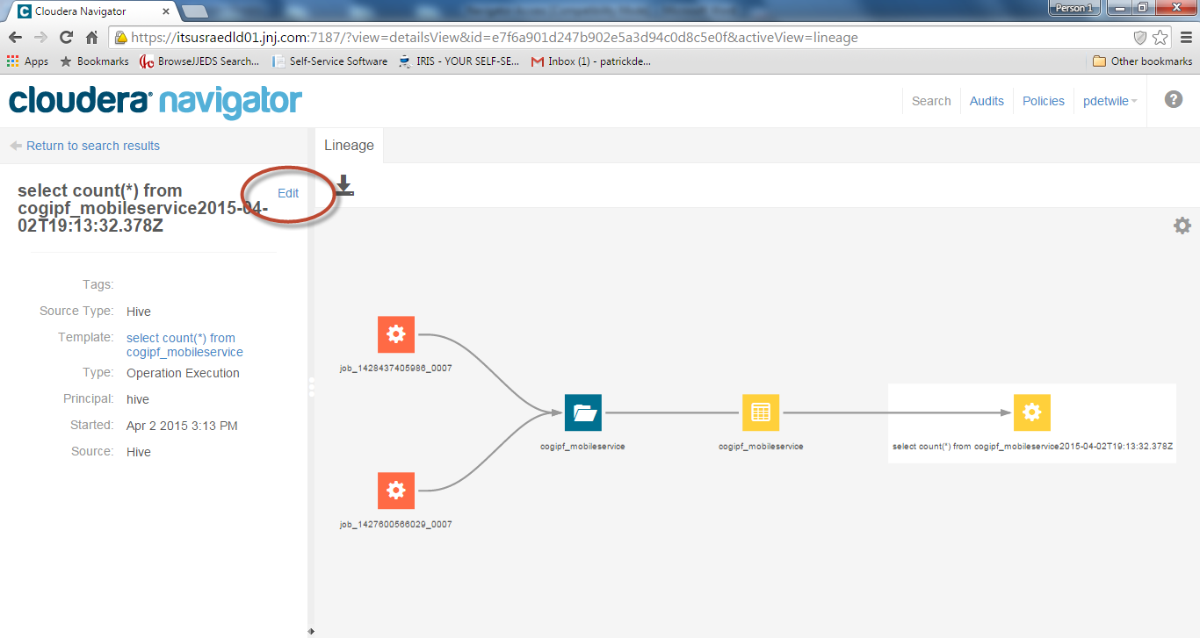

- Edit fields that are applicable

